Ayush Sharma 2 April 2018

(150123046)

Question 1.

1. Provided with “Part B”.
2. The Tables are following:
   1. BSE Call Option Prices (over varying K) : bseoptc_k.csv
   2. BSE Put Option Prices (over varying K) : bseoptp_k.csv
   3. NSE Call Option Prices (over varying K) : nseoptc_k.csv
   4. NSE Put Option Prices (over varying K) : nseoptp_k.csv
3. The Tables are following:
   1. Volatility:
      1. BSE Historical Volatility (over varying time period considered) : bselt_vol.csv
      2. NSE Historical Volatility (over varying time period considered) : nselt_vol.csv
   2. Option Prices (based on the Historical Volatility):
      1. BSE Call Option Prices calculated on Historical Volatility (over varying time period considered) : bseoptc_t.csv
      2. BSE Put Option Prices calculated on Historical Volatility (over varying time period considered) : bseoptp_t.csv
      3. NSE Call Option Prices calculated on Historical Volatility (over varying time period considered) : nseoptc_t.csv
      4. NSE Put Option Prices calculated on Historical Volatility (over varying time period considered) : nseoptp_t.csv

The Plots of the volatility and the option prices against the corresponding length of the period considered are following:

1. Volatility: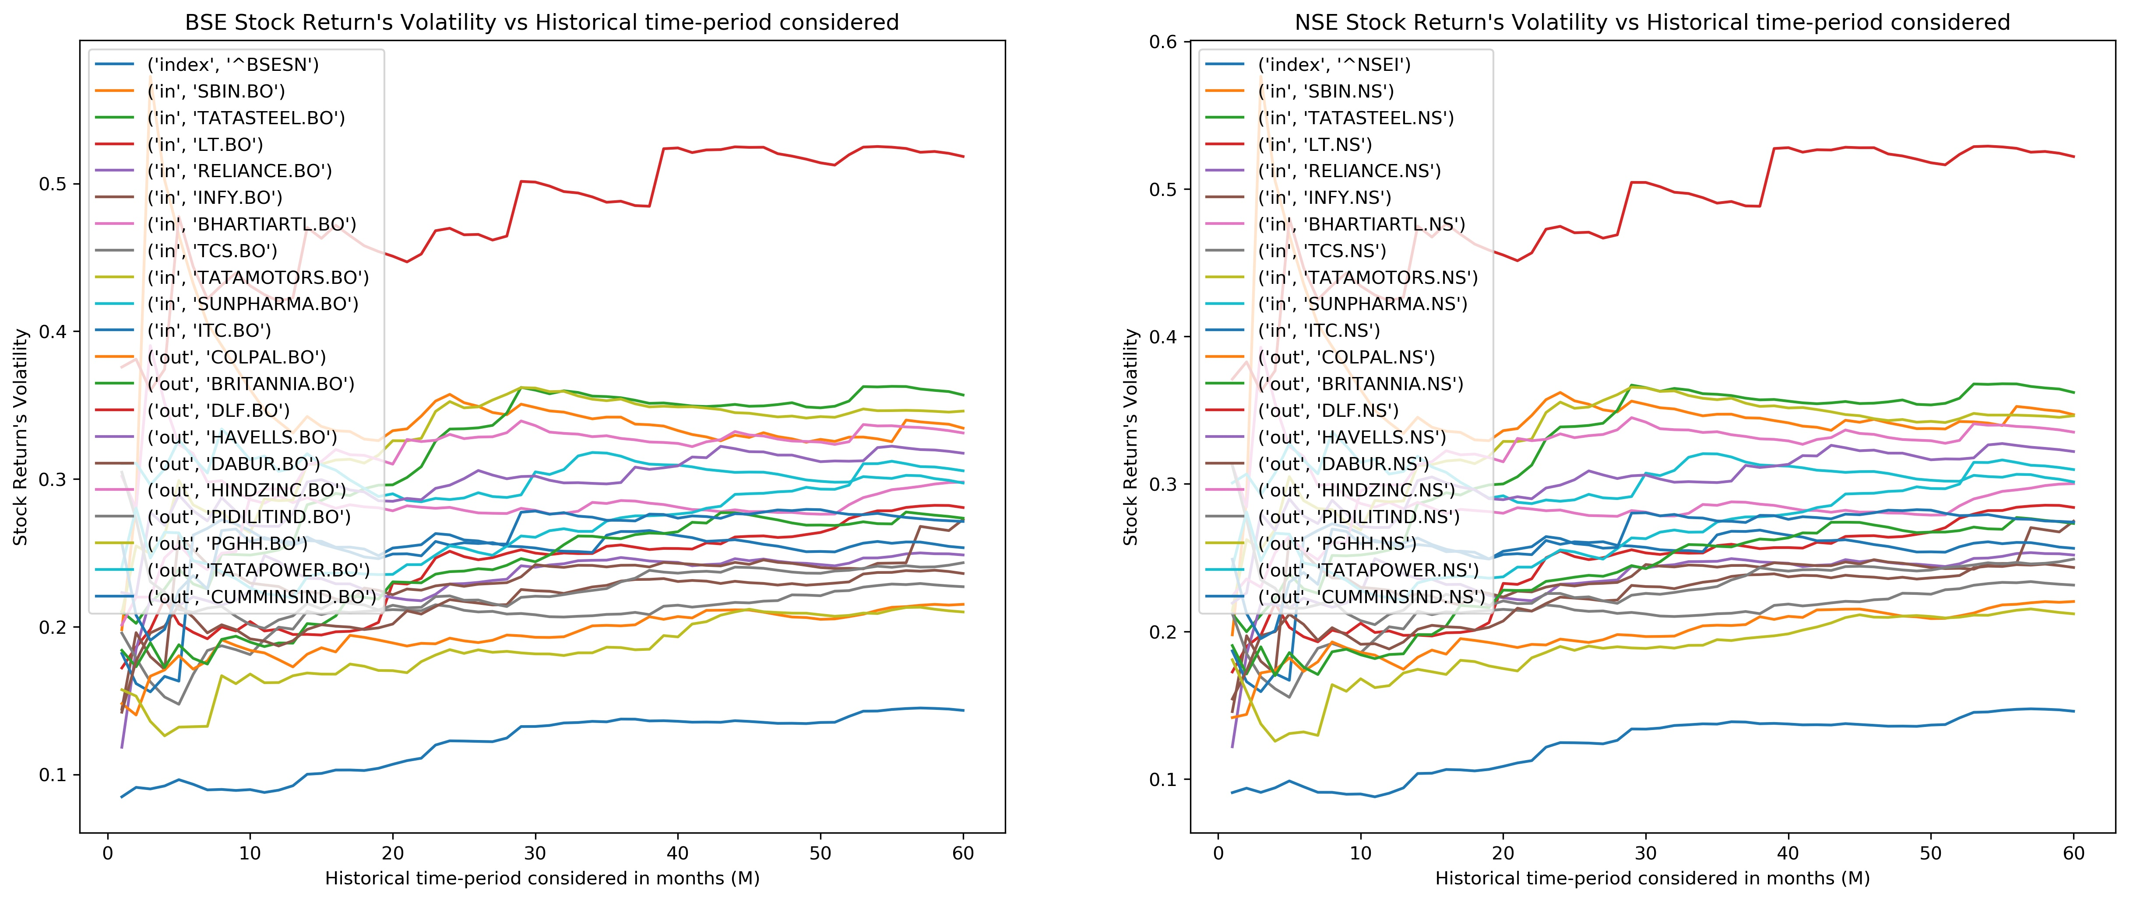
2. Option Prices: